**Stage 6 – Full Moon🌕**

**RULES:** USPSA Competition Rules, Latest Edition **COURSE DESIGNER:** Ike Starnes

|  |  |
| --- | --- |
| **START POSITION: See written stage briefing.** | |
| **STAGE PROCEDURE**  See written stage briefing. | **SCORING**  **SCORING:** Virgina count 12 rounds.  **TARGETS:** There are 6 cardboard targets.  **SCORED HITS:** 2 Best hits per carboard will be scored.  **START-STOP:**  Audible - Last shot  **PENALTIES:** Per USPSA Competition Rules |

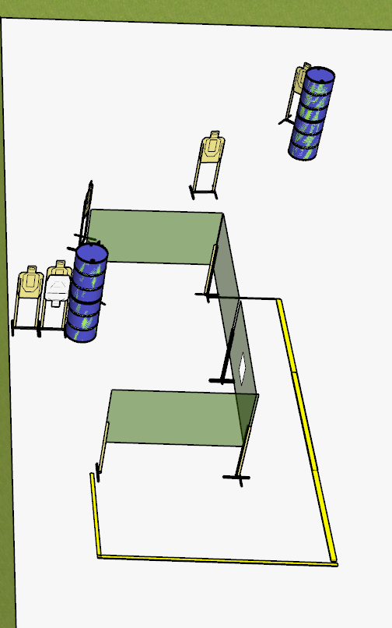

**Written Stage Briefing:**

**Stage 6 – Full Moon🌕 –** is a **12-round**, **60** point, **Virginia Count** Short Course. There are **6 cardboard** targets. The best **2 hits** per cardboard target will be scored.

**Start position**

Handgun: Both feet inside the shooting area. Handgun is loaded and holstered, wrists below belt.

PCC: Both feet inside the shooting area. PCC is loaded, stock on belt.

On the audible start signal, engage targets from within the shooting area.

**Setup Notes:**

Ensure that the most downrange paper target can only be engaged from the front left corner of the shooting area. If you have to use more barrels, then please do so.

Ensure that the most downrange paper target has no shoot through into the classifier stage.

2 Single Wall Stands

3 Double Wall Stands

3 Solid Walls

1 Ported Wall

6 Target stands / 12 target sticks

4+ barrels